Testing

**LOGIN Page:**

1. Logged in using normal creds as well as google. But facing issue in LinkedIn Login.

Refer the video for the same.

**BLOG Page:**

1. The old tags value should be preserved while updating like title and description
2. It should ask for the confirmation for deletion (it should not instantly delete the blog)
3. The search in the blog page is not working
4. Comments are not there on blog page
5. It should be sharable on social platforms
6. Pagination is enabled on not on blogs. If yes, then on what numbers?

**PROBLEMS Page**

1. By default (random problems should be visible even if no selection is done on the basis of difficulty
2. It is not testing the same problem mentioned in the question.
3. submission part is not dynamic
4. Discussion (particular problem) part is left.
5. Similar Problems should redirect to the similar kind of problems not the all problems page.
6. Latest Submission is not dynamic.
7. The data in the problems are static.

**ADMIN Page:**

1. Manage Users - > Modify Problems on any user -> then press upper back (there are twos backs which is not needed and also not placed properly)-> manage is not clickable and the page goes blank. (need to refresh the page)
2. Modify Problems on any user is some times not clickable when we press the second back.
3. Delete is not functional. (use the confirmation prompt for a user).
4. Create Admin is not functional.
5. Tutorial is simple text based (text markup should be enabled).
6. Problems format is also simple.
7. Problems are created in admin page. But not present when logged in by normal user.
8. use the confirmation prompt for a problem deletion.

**Design Issues: (Chrome)**

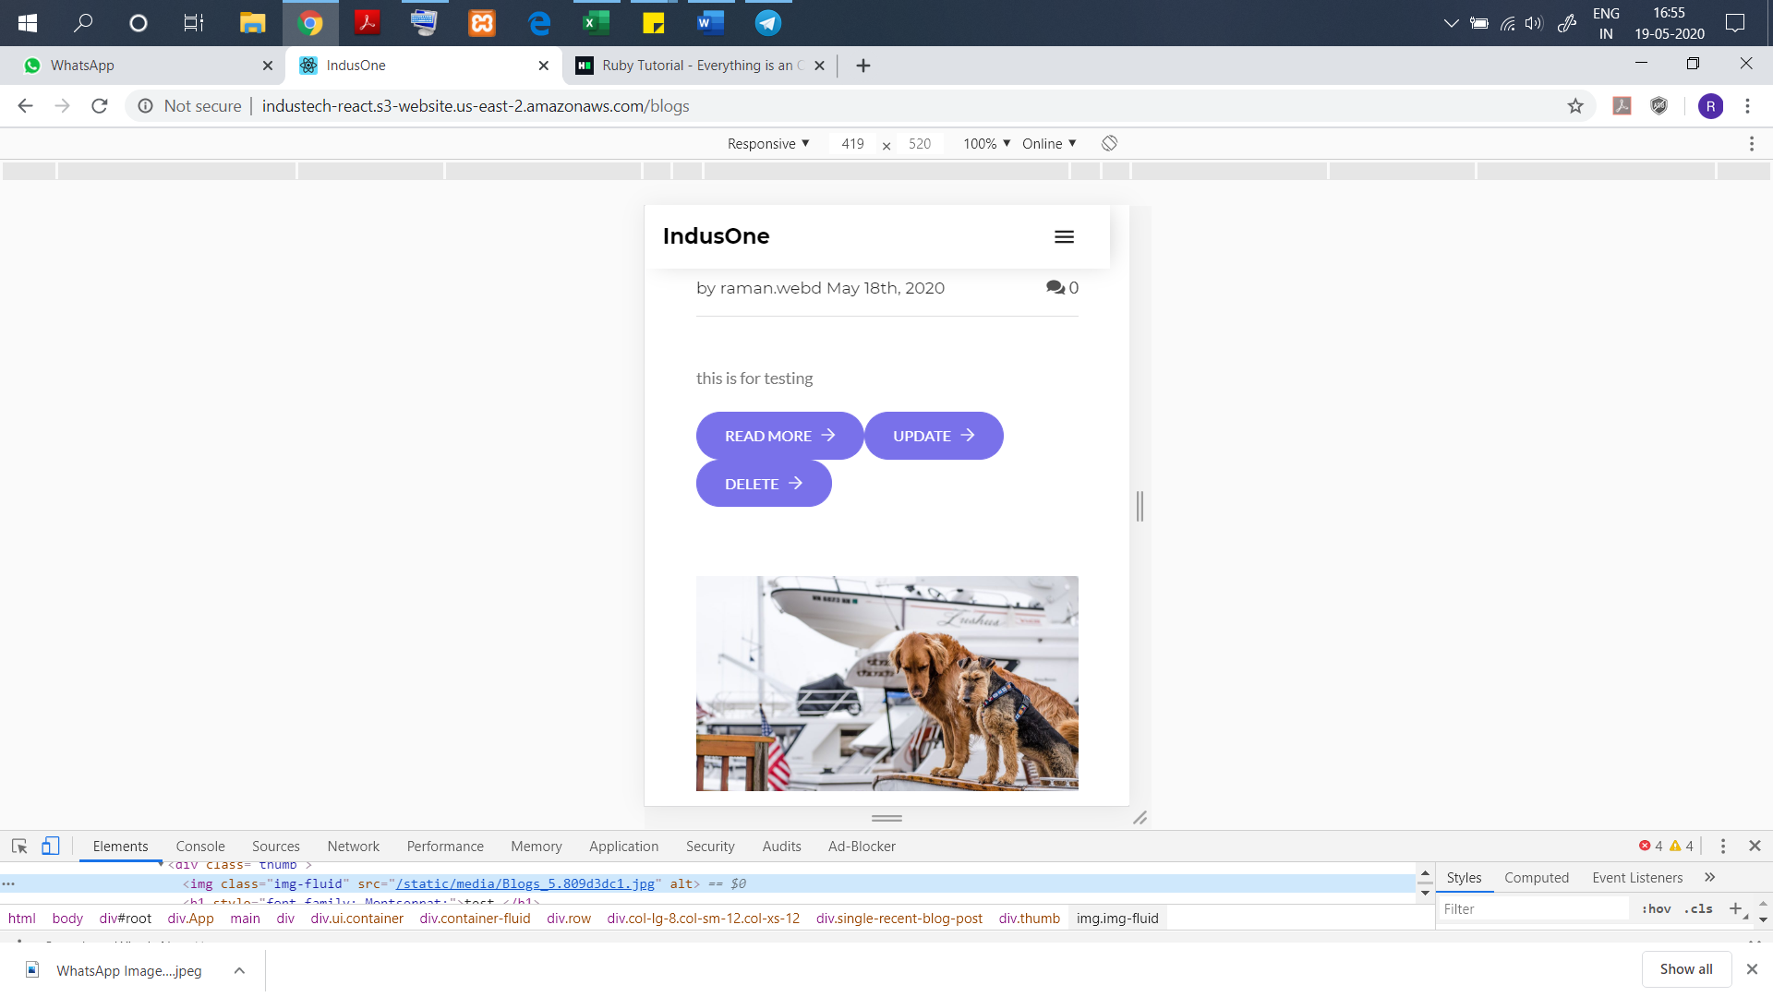

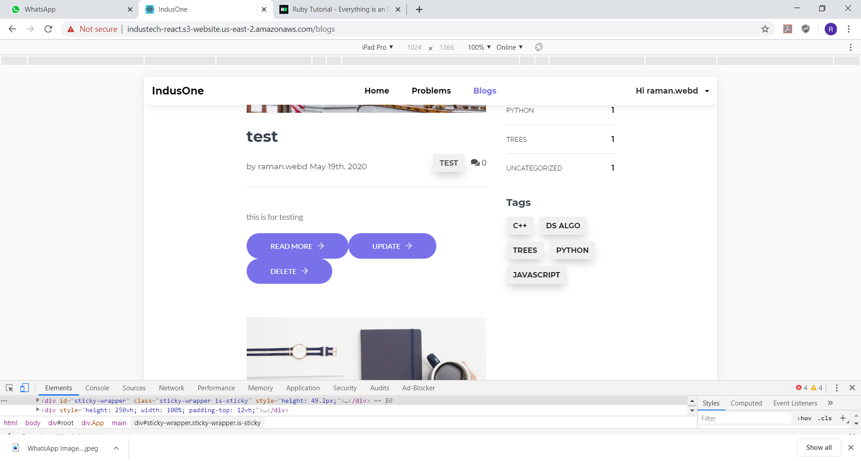

1. there should be little space between the buttons

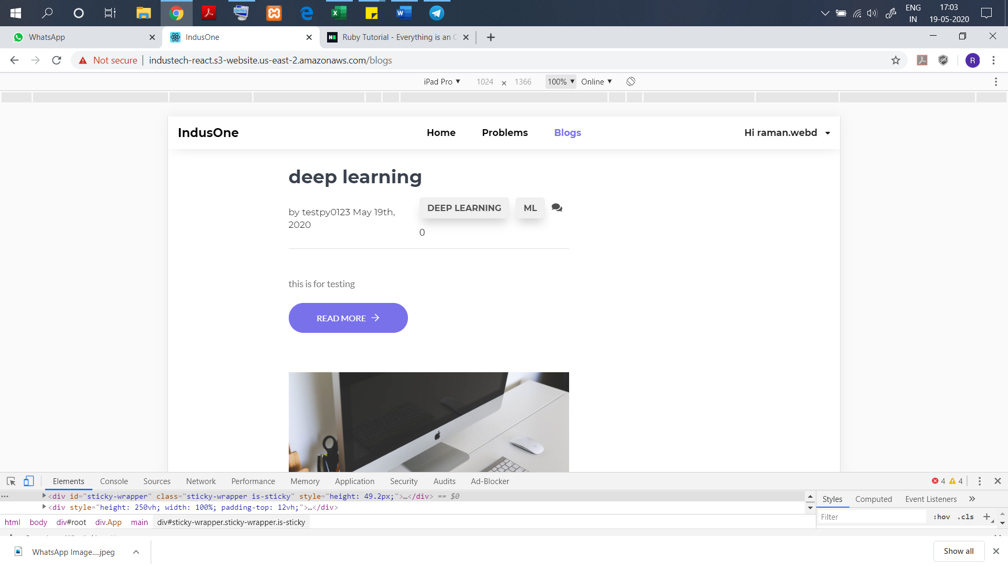

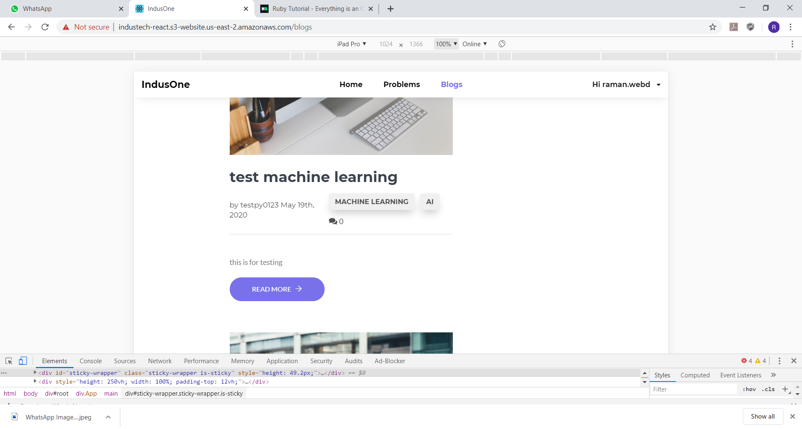

1. Check the comments numbers get displaced on increasing numbers of tags.
2. 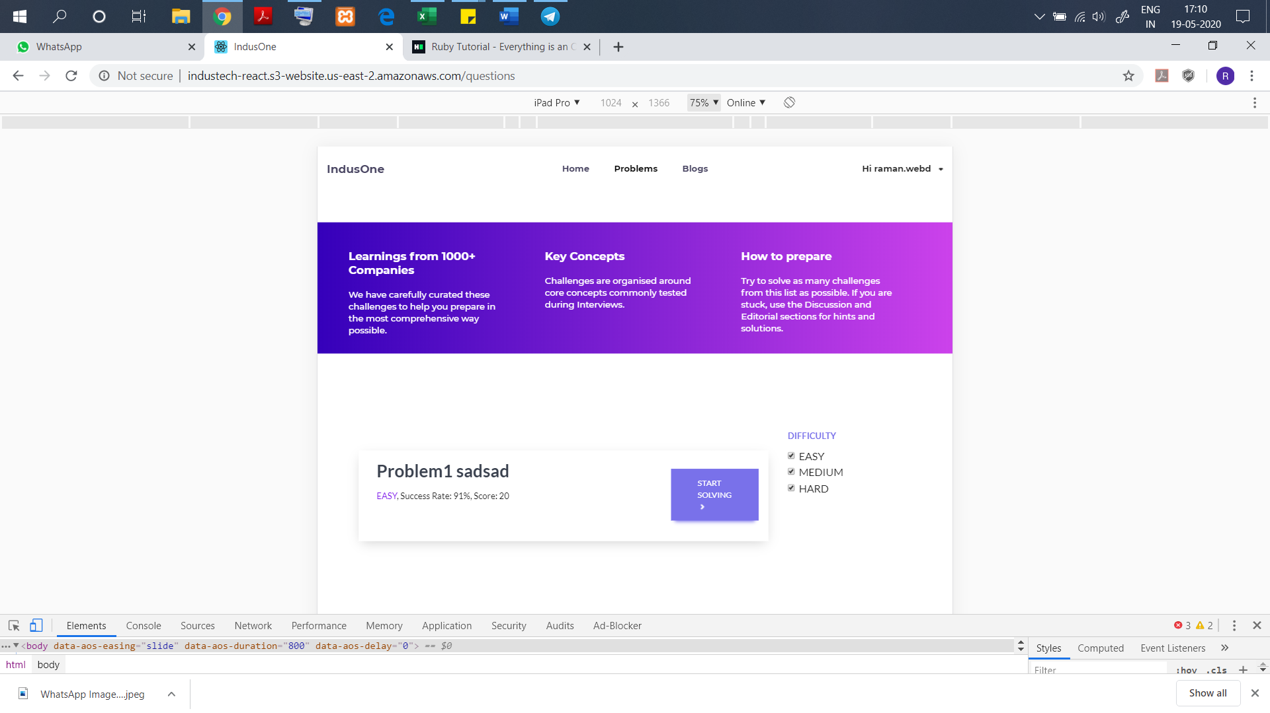

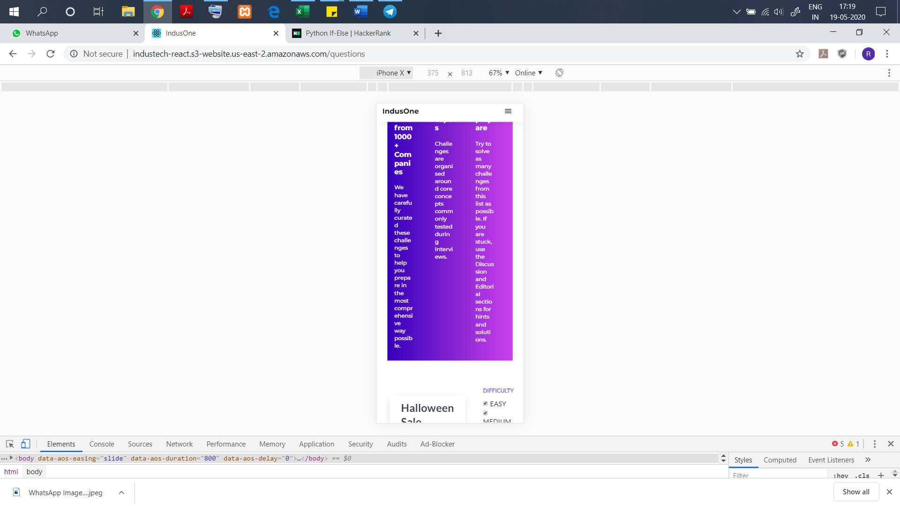

1. In the case Phones(smaller screen this purple area and the difficulty can be removed so that the full area can be occupied by the questions and can be clearly readable.

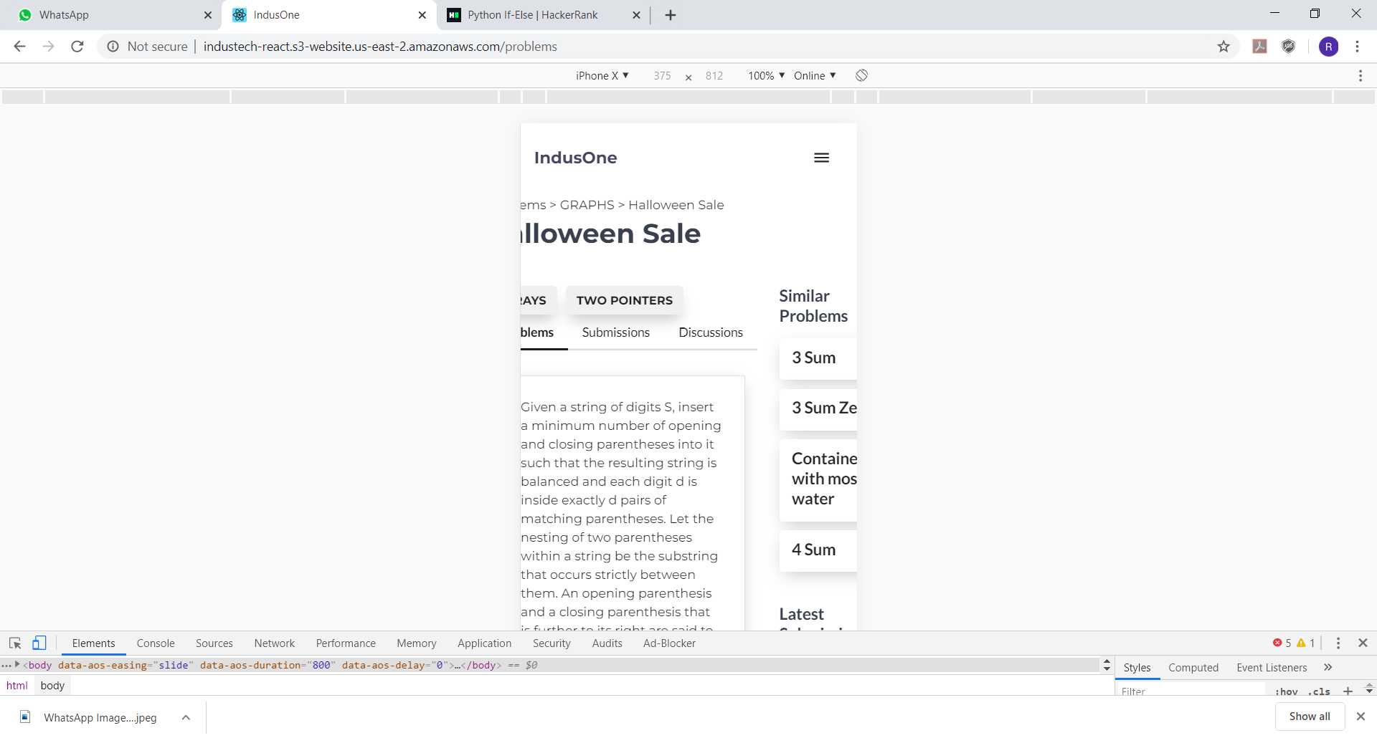

1. The question is getting cut in iPhone-X and many other devices.

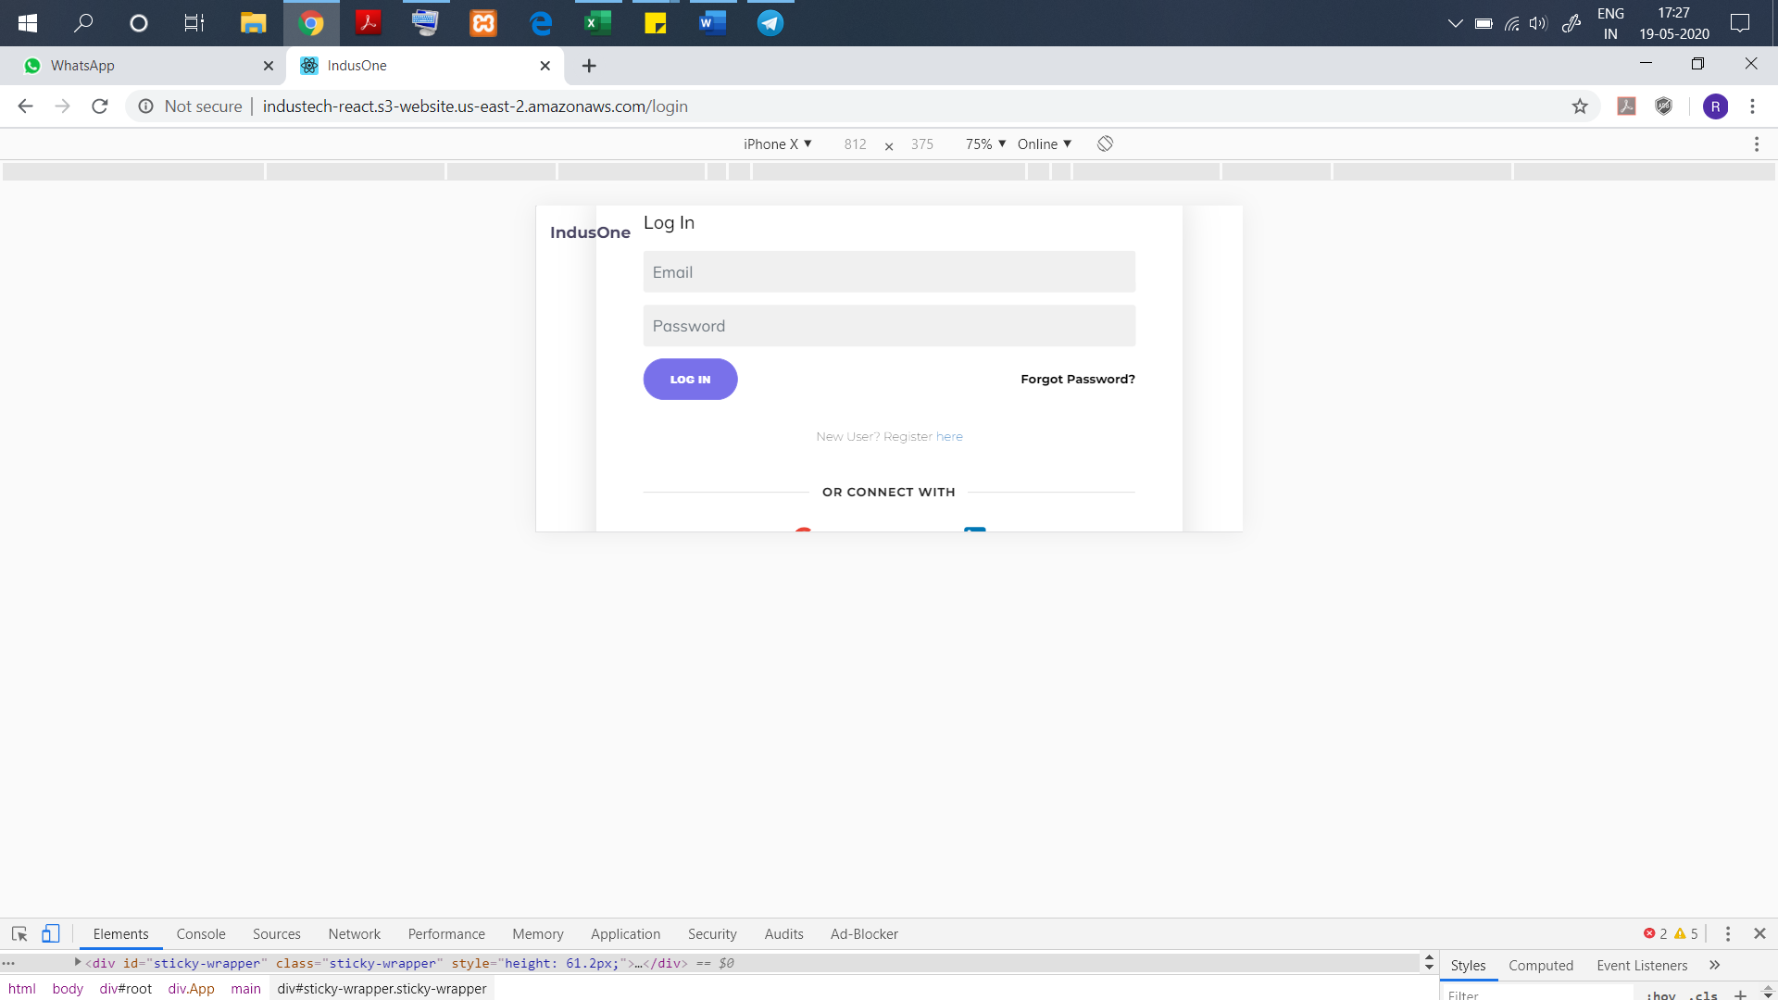

1. Login modal in all phone devices.
2. 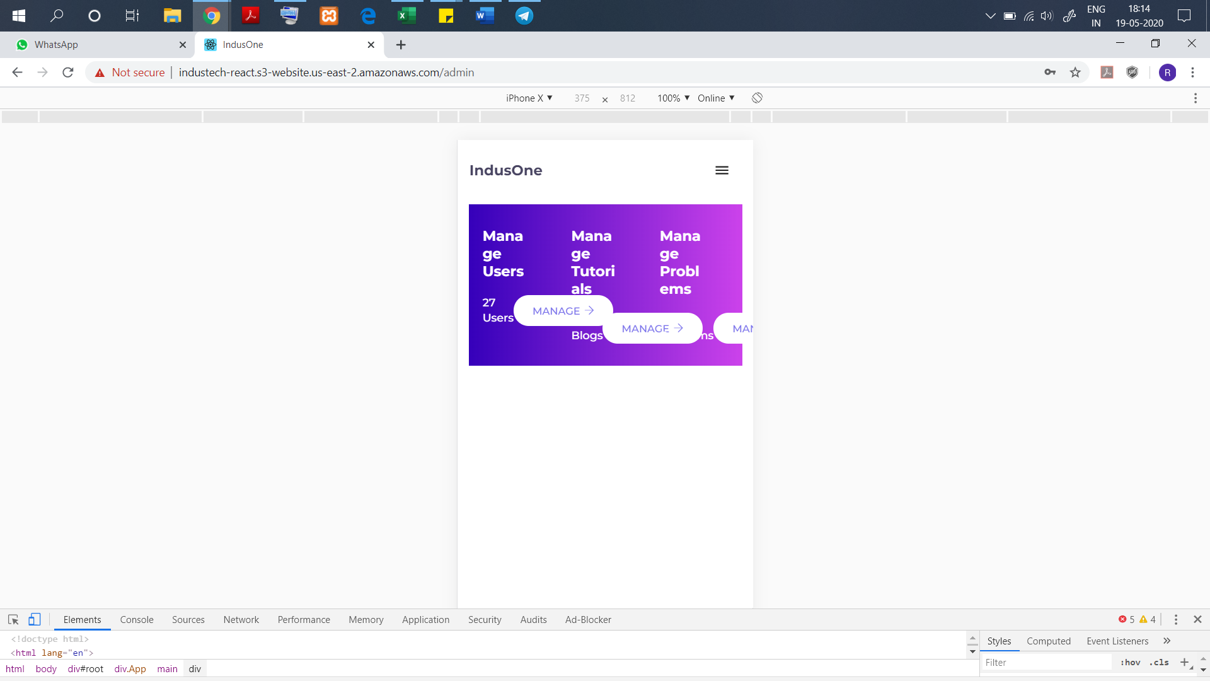

**Design Issues: (IE)**

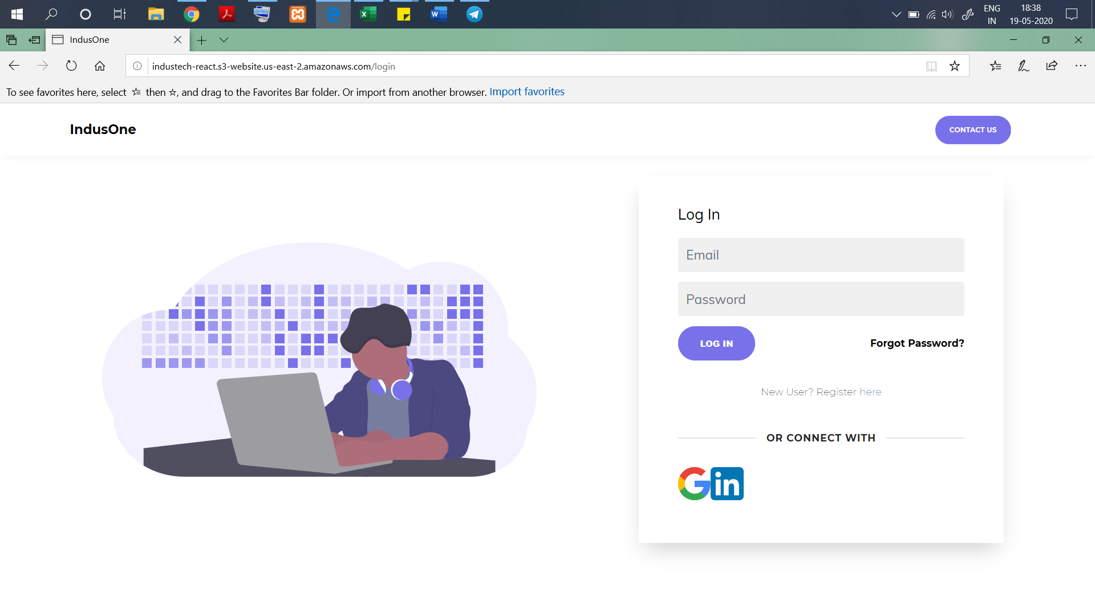

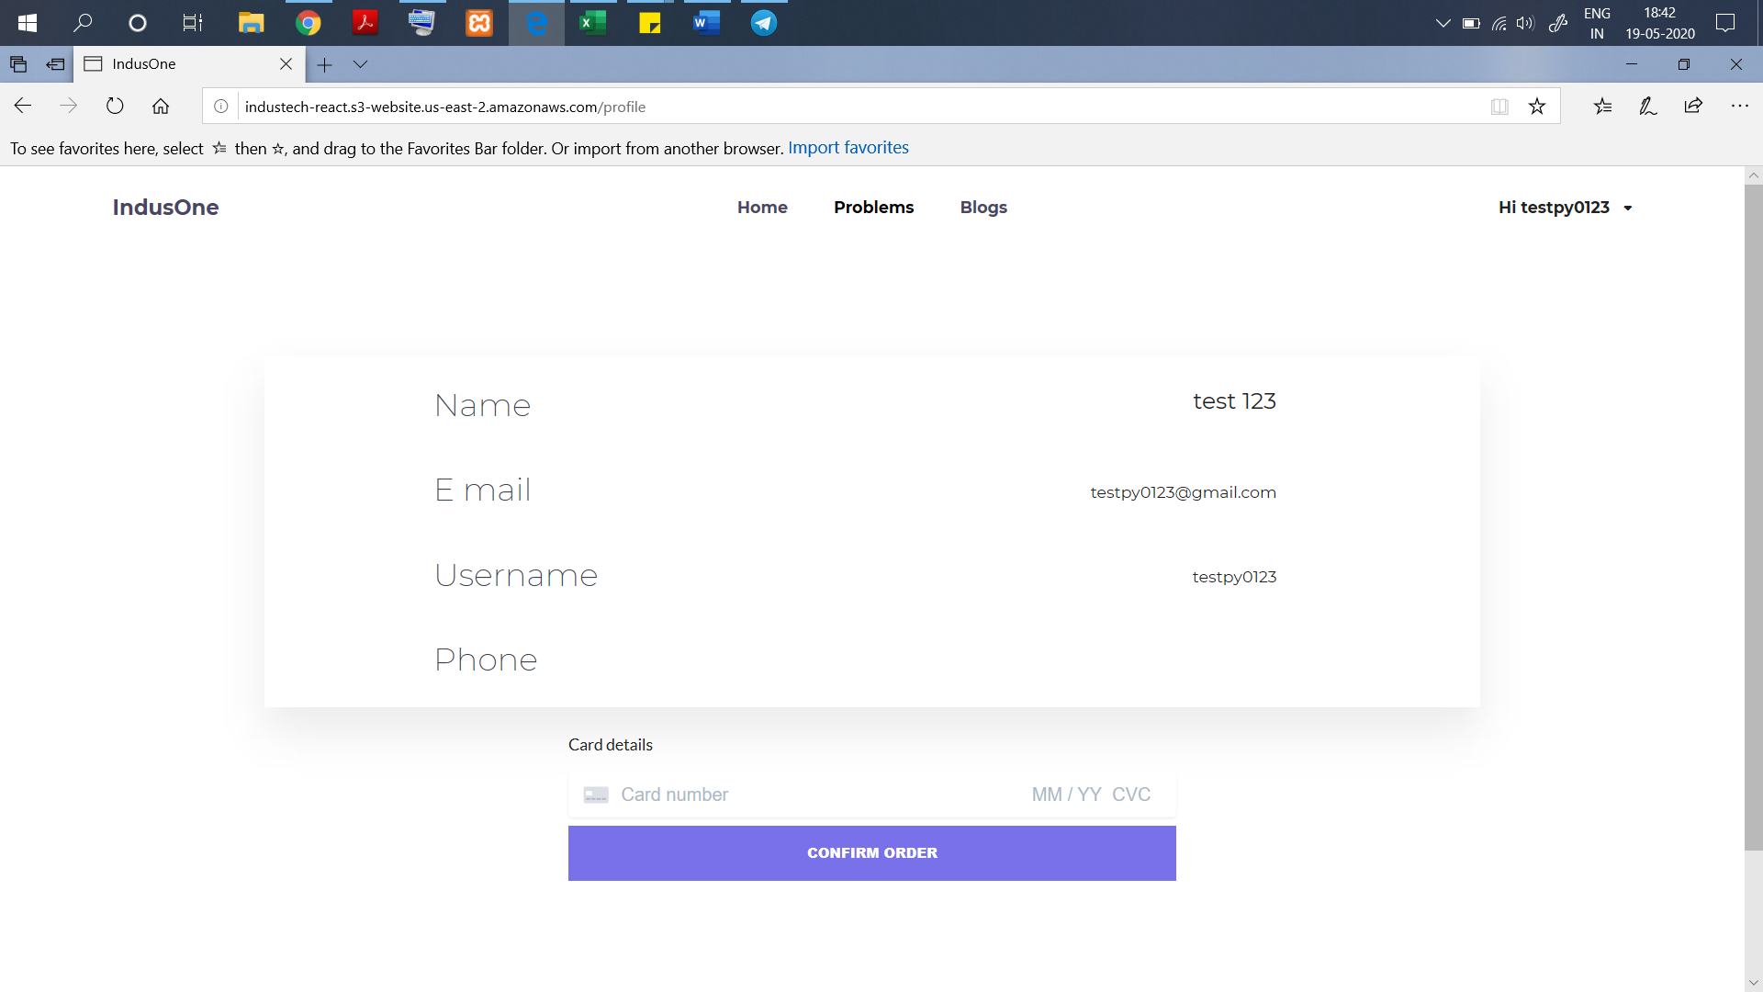

**This needs to be improved.**

**The Rest functionalities:**

1. **Discussion Forum (subject, body, reply, comments (stack overflow))**
2. **AI Connect**
3. **Problem Discussion**
4. **User Dashboard (Skills, Report , Skills to improve(recommendations)**
5. **Text based, video and audio (quizzes at the end of the topic)**
6. **Test(evaluation) 🡪 for full course(paid)**
7. **Machine Learning testing**
8. **Payment Gateway (needs to be discussed)**
9. **ChatBot**
10. **Login using GitHub**